Abilene Christian University
Department of Biology, 1600 Campus Court, Abilene, TX 79699
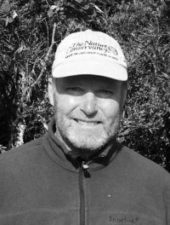
Tom Lee
Phone: 325-370-4442
Email: leet@acu.edu

Research Interests, Projects, and Grants:
In 2024, I used my Clark Stevens endowed professorship funds to travel to the American Society of Mammalogists meetings in Boulder, Colorado. I presented Data on a survey of mammals of Cerro de Arcos, Loja, Ecuador that was present as TSM in 2024.

Furthermore, I conducted research in the lab on sequencing DNA and examining the morphology of members of the genus Thomasomys this past summer. The study was on Thomasomys cinnameus and Thomasomys hudsoni and these data will be presented at TSM 2025 by Cindy Cho.

I now have all of the equipment for digitization and cataloging of the Abilene Christian Natural History Collection. This means I cataloged and photographed a lot of insects over the summer.

Undergraduate Students and Their Research:

My student Cindy Cho and I are finishing a study on a better characterization of two species of Thomasomys using both morphologically and genetics.

My students Taylor Hickman, Lydia Szabo, and Lyndsey Klein conducted a camera trapping survey at Abilene State Park in 2024. This project is the sixth camera trapping year for the Abilene State Park. This study is part of the SNAPSHOT camera-trapping program and Wildlife Insights. These data will be presented at TSM. Data from the camera trapping of Abilene State Park have been combined with national and international studies and published in Nature ecology and evolution, Ecology and Diversity and Distributions in 2024.

Angelo State University
Department of Biology, San Angelo, TX 76909
Edson F. Abreu
Phone: 325-486-6656
Email: Edson.abreu@angelo.edu
Web page: https://eabreu.weebly.com/

Research Interests, Projects, and Grants:
I am a Brazilian mammalogist and an Assistant Professor in the Department of Biology at Angelo State University (ASU), where I also serve as the Curator of Mammals at the Angelo State Natural History Collections (ASNHC). My research focuses on the discovery and recognition of mammalian diversity at multiple scales, from intraspecific genetic and morphological variation to taxonomic classification and community assemblages. I am particularly interested in the evolutionary and ecological processes that generate and maintain the extraordinary biodiversity of the Neotropics.
My research integrates fieldwork, museum-based taxonomy, and molecular systematics to elucidate cryptic diversity and evolutionary relationships within mammals. Recent efforts have centered on tree squirrels, utilizing genomic data from museum specimens and field-collected samples to investigate phylogenetic relationships, diversification patterns, and historical biogeography.

I maintain research associate appointments with the University of São Paulo (Piracicaba, Brazil), the Center for Conservation Genomics at the Smithsonian Institution (Washington D.C.), and the American Museum of Natural History (New York).

Additional Information:
My research spans macroevolutionary studies of globally distributed taxa, investigations of intraspecific genetic and morphological variation, and disciplines such as molecular phylogenetics, historical biogeography, and comparative morphology.

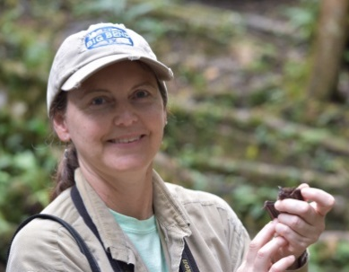
Loren K. Ammerman
Phone: 325-486-6643
Email: loren.ammerman@angelo.edu
Web page: www.angelo.edu/content/profiles/75-loren-k-ammerman

Research Interests, Projects, and Grants:
I am interested in bats and other mammals. I work with students to use molecular data to reconstruct evolutionary relationships of organisms, to investigate genetic diversity, and to understand diet. I also am interested in distribution, community structure, and the ecology of bats, especially in Texas. Most recently I have been monitoring seasonal roost use, movements, and colony size fluctuation of Leptonycteris nivalis in Big Bend National Park.
See my ResearchGate profile https://www.researchgate.net/profile/Loren-Ammerman for recent publications.

Current Graduate Students and Their Research:
- Kennedy Berry – MS thesis student, Bat activity in west Texas based on acoustic detections along a transect (Graduate Assistant, Fall 2023 – present)
- Flor Calderón – MS thesis student, Foraging behavior of Mexican long-nosed bats (Leptonycteris nivalis) in the Chisos Mountains of Texas (Graduate Research Assistant, Summer 2023- present)
- Ashley Loehn– MS thesis student, Factors influencing detection of Leptonycteris nivalis in Emory Cave using airborne eDNA (Graduate Research Fellow, Fall 2023 -present)

Current Undergraduate Students and Their Research:
- Daniela Childress – DNA barcoding of Peromyscus specimens from high elevations in Texas (Undergraduate Research, Fall 2024-present)
- Halle Summers – Exploring species boundaries in cryptic species (Myotis californicus and M. ciliolabrum) using a genomic approach (ASU Undergraduate Research Scholar, Fall 2024-present)

Additional Information: The Angelo State Natural History Collection has over 21,000 mammal specimens and over 35,000 tissue specimens. The collection is searchable via Arctos at https://www.angelo.edu/dept/asnhc/collections.php and on VertNet and GBIF. You can contact me if you have any questions about the collection.

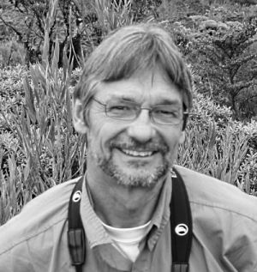
Robert C. Dowler (Retired)
Phone: 325-486-6639
Email: robert.dowler@angelo.edu

Research Interests, Projects, and Grants:
My research interests in retirement continue to be on spatial ecology of skunks in Texas. I am currently finishing up projects with Clint Perkins and Richard Stevens on the plains spotted skunk (Spilogale interrupta) in Texas, as well as assessing the status of hooded skunks (Mephitis macroura) in Trans-Pecos Texas. I continue to have interest in all skunk species in Texas, porcupine dermatophytosis, and the conservation biology and systematics of Galapagos endemic rodents.
Graduate Students and Their Research:
- J. Clint Perkins, former M.S. student is now a Ph.D. student at Texas Tech University working on the spatial ecology of populations of plains spotted skunks at the Katy Prairie. I am co-advisor with Dr. Richard Stevens at TTU.

Baylor University
Department of Biology, Waco, TX 76798
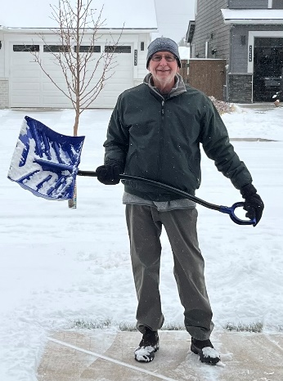
Kenneth T. Wilkins (Retired)
Phone: (254) 709-7211
Email: ken_wilkins@baylor.edu

After 39 years on the faculty at Baylor University, including 24 years in administration, I have retired. We have taken the Oregon Trail to the Pacific Northwest. We now live in Bend, a vibrant community situated in an ecotone spanning the Ponderosa forest of the lower slopes of the
Cascade Range to the juniper scrub of the High Desert at the western extent of the Great Basin. The book written by fellow mammalogists BJ Verts and Leslie Carraway is a tremendous guide
to landforms, flora and the mammals of Oregon!

Of interest to Texas mammalogists is that the Department of Biology mammal collection has been transferred to a location on the Baylor campus that should ensure its care in perpetuity and its availability to researchers. The collection is now housed in Mayborn Museum, a larger museum complex that incorporates the former Strecker Museum.
A teaching collection remains with the Department of Biology, but the research caliber materials transferred to Mayborn Museum. The research collection comprises c. 2,000 specimens (predominantly skin & skull preparations of rodents and bats) mainly from Texas. The specimens represent vouchers from an array of projects: surveys on Texas Parks & Wildlife properties (Fort Parker State Park, Lake Fairfield State Park, Hill Country State Natural Area), population and community studies on Texas Nature Conservancy properties (Clymer Meadow, Leonhardt Prairie), and numerous master’s theses and doctoral dissertations conducted at these and other locations. There are a few specimens from Mexico, collected in association with teaching and research at Chapala Ecology Station in Jalisco from 1992 through 2001. Inquiries related to the collection should be directed to Ms. Anita Benedict, Collections Manager at Mayborn Museum.

Cameron University
Lawton, OK 73505

Dana N. Lee
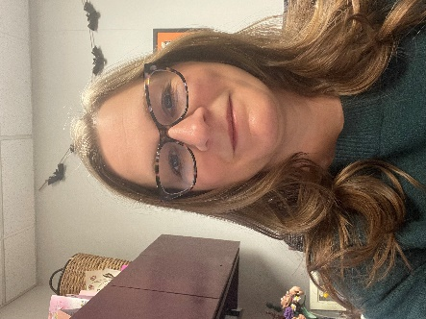
Phone: 580-591-8009
Email: dalee@cameron.edu

Research Interests, Projects, and Grants:

I primarily study bats and am interested in all aspects of their ecology, genetics, and evolutionary relationships; although, I use molecular biology tools to study the genetic variation of other wildlife populations. Undergraduate students in my lab are currently working to determine the diet of the ghost-faced bat and the pallid pat using molecular analysis. We are also screening bats for adenoviruses and microplastics.

Centenary College of Louisiana
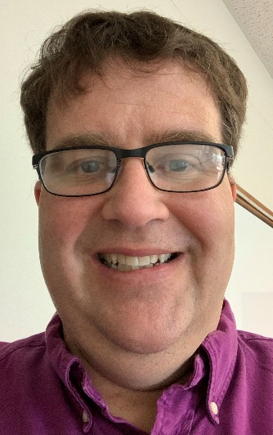
2911 Centenary Blvd., Shreveport, LA 71104
Scott Chirhart
Phone: 318-869-5209
Email: schirhar@centenary.edu

Research Interests, Projects, and Grants:
Evolutionary Biology, including: Evolutionary/Population Genetics, Vertebrate Speciation and Systematics, Molecular Variation

Houston Museum of Natural Science
Dept. of Vertebrate Zoology, 5555 Herman Park Dr., Houston, TX 77030-1799
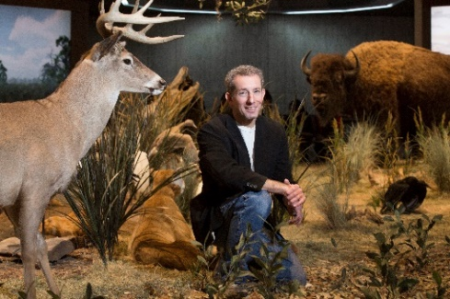
Dan Brooks
Phone: 713-639-4776
Email: dbrooks@hmns.org
Web page URL: www.hmns.org/exhibits/curators

Research Interests, Projects, and Grants:
Although I do quite a bit of work with birds, research interests in mammalogy span a variety of topics including community and behavioral ecology, biogeography and taxonomy, harvest patterns, natural history, and conservation. I am particularly interested in Neotropical species in lowland regions east of the South American Andes (especially the Peruvian Amazon, Paraguayan Chaco, and eastern Bolivia). Additional regions of coverage include Texas, Middle America, SubSaharan Africa, and more recently Southeast Asia.

Current mammalogy projects I’m involved with include:
- The Houston Urban Wildlife Project (HUWP) features a section on urban mammal projects that we’re involved in (www.hmns.org/huwp).
- Tim McSweeny and I are partnering with Buffalo Bayou Partnership inventorying mammals through film bytes of camera traps, with accounts on specific natural history information. We are amazed that coyotes, beavers, otters, etc can be found < 1 mile west of downtown Houston!

Additional Information: The primary driver of the Houston Museum of Natural Science is Education, including outreach. We educate every 4th and 7th grader in the Houston Independent School District annually (approx. 700,000 students/yr), have nearly 2.5 million individuals come through the doors per annum, and are the 4th highest attended museum in the country; surpassed only by Smithsonian, AMNH, and the MOMA. We are the highest attended US museum west of the Mississippi. Every year I tour college-level classes through our collections and permanent wildlife exhibit halls. If you have any interest in coming for a visit just touch base directly!

Interquest Environmental Consultants
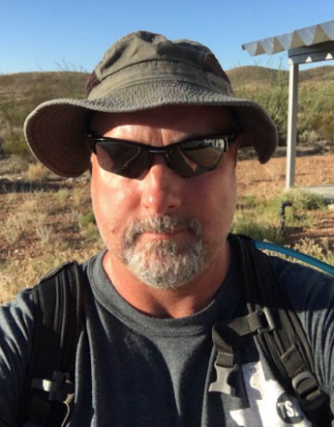
Ray E. Willis
Phone: 806-787-0283
Email: raywillis.interquest@gmail.com

Research Interests, Projects, and Grants:
Private Wildlife Contracts and Surveys. After spending thirteen years in academia, I decided to switch my focus to private wildlife contracts with an emphasis on surveys for business and large ranches. Additionally, I provide solutions for urban wildlife problems and land management for newly developed rural neighborhoods. I am expecting to expand in the future and will need qualified vertebrate biologists for potential subcontracting opportunities.

McMurry University
Department of Biology, Abilene, TX 79697
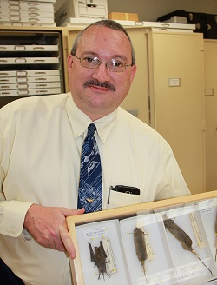
Joel G. Brant
Phone: 325-793-3875
Email: brant.joel@mcm.edu

Research Interests, Projects, and Grants:
My research interests are primarily concerned with the natural history of mammals, particularly in Texas and the Chihuahuan Desert. My current research program focuses on the natural history & ecology of mammals in the Southern Rolling Plains, northern Edwards Plateau, and northeastern Chihuahuan Desert. My current projects include a survey of the mammals of the Southern Rolling Plains, specifically Taylor County & surrounding areas (with Tom Lee); assessing the ecological impacts of wind farms on bat diversity; and various mammal, herp, and bird projects associated with Firebase Libby, a property owned by McMurry University located in Callahan County, Texas.

Purdue University
West Lafayette, IN
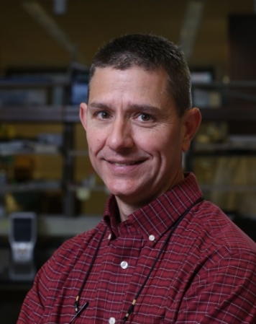
J. Andrew DeWoody
Phone: 765-496-6109
Email: dewoody@purdue.edu
Web page: https://web.ics.purdue.edu/~dewoody/DeWoody/wordpress/

Research Interests, Projects, and Grants:
Evolutionary genetics and genomics; molecular ecology and evolution; natural history; conservation biology; wildlife and fisheries management. Our research occurs at the intersection of ecology, evolution, conservation, and genomics. Ongoing or recent projects have centered on the distribution of genomic diversity in threatened or endangered (T&E) fishes, herps, birds, and a variety of mammals including marsupials, rodents, and cetaceans.

Graduate Students and Their Research:
My graduate students and postdocs work on a variety of questions in ecology and evolution, including important conservation issues related to T&E species (e.g., gray whale population structure). Students matriculate through either the Biology program or a Wildlife program.

Undergraduate Students and Their Research:
My undergraduates are all mentored by graduate students or postdocs. Most start as “assistants,” but the best students develop their own research projects.

Additional Information:
I am always looking for bright, motivated students so please contact me if you are interested in an immersive experience at a top-notch graduate school. See my webpage for more details.

Tarleton State University
Department of Biological Sciences, Stephenville, TX 76402


Philip D. Sudman (Retired)
Phone: 254-968-9154
Email:sudman@tarleton.edu
Web page URL: faculty.tarleton.edu/sudman/

Research Interests, Projects, and Grants:
After retiring last July, I have been busy chasing our dog, golfing, fishing, camping and brewing beer. I remain active as Secretary-Treasurer and Trustee of the American Society of Mammalogists, and I hope to spend time over the next several months compiling data from past research and submitting a few mammal related notes. I am also hopeful that I will be able to continue working with Tarleton’s study abroad program – the past two summers I have spent several weeks with students trapping small mammals in the central Kalahari of Botswana (elephant shrews, gerbils, fat mice, pouched mice and rock rats to name a few). It has been a great way to end my career and I am always game to learn new things!


Russell S. Pfau
Phone: 254-968-9761
Email: pfau@tarleton.edu
Web page: faculty.tarleton.edu/pfau/

Research Interests, Projects, and Grants:
My main research focus is population and evolutionary genetics—often with a focus on conservation biology. Small mammals have been the primary subject of my research, but my taxonomic coverage has recently included crustaceans, fish, plants, frogs, and insects. Ongoing projects include:
- Documentation and assessment of contact zones between Geomys bursarius and G. breviceps in southern Oklahoma and northern Texas
- Population genetics and soil-type correlations of Geomys texensis.
- Distribution of shrews (Blarina) in the southern Great Plains region using mtDNA sequencing (for identification) and morphometric analysis to examine geographical patterns of variation
- Species status of two bumblebees in Texas
- Phylogenetics and species discovery among Texas anemones (windflowers)
- Conservation genetics of the crawfish frog

Recent publications:
- Beckham, J. L., Johnson, J. A., & Pfau, R. S. (2024). Molecular data support Bombus sonorus and Bombus pensylvanicus (Hymenoptera, Apidae) as distinct species. Journal of Hymenoptera Research, 97, 895-914.
- Pfau, R. S., Kozora, A. N., Gatica‐Colima, A. B., & Sudman, P. D. (2023). Population genetic structure of a Chihuahuan Desert endemic mammal, the desert pocket gopher, Geomys arenarius. Ecology and Evolution, 13(10), e10576.


Jenna R. Grimshaw
Phone: 254-968-9158
Email: jgrimshaw@tarleton.edu

Research Interests, Projects, and Grants:
My main research interest is analyzing transposable elements (TEs) in mammalian genomes from a macroecological perspective. As TEs vary in diversity and distribution within and among genomes, TEs may behave similarly as species in ecological communities. Therefore, common macroecological analyses such as species abundance distributions and co-occurrence analyses may provide insights on how TEs interact with each other and their genomic environment. My other research interest is in bat population genetics especially Myotis septentrionalis.

Recent Publications:
Grimshaw, JR., Donner, D., Perry, R., Ford, W.M., Silvis, A., Garcia, C.J., Stevens, R.D., and Ray, D.A. (2024). Disentangling genetic diversity of Myotis septentrionalis: population structure, demographic history, and effective population size. Journal of Mammalogy, 105(4): 854-864.

Texas A&M Natural Resources Institute
1919 Oakwell Farms Parkway, Suite 100, San Antonio, Texas 78218

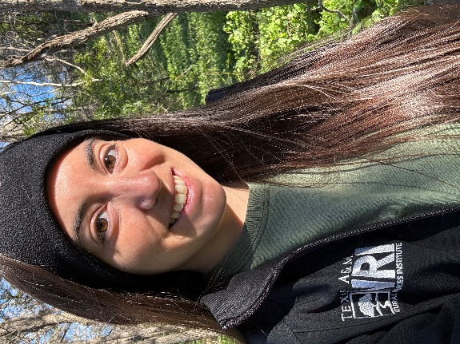
Stephanie Martinez-Brewer
Phone: N/A
Email: Stephanie.martinez@ag.tamu.edu
Web page: https://nri.tamu.edu/people/research/stephanie-brewer/
Research Interests, Projects, and Grants:
I am a senior research and policy associate for Texas A&M Natural Resources Institute. I support the conservation of nationwide declining, threatened and endangered species by working with the U.S. Fish and Wildlife Service and state and other federal partners to build Species Status Assessments (SSAs) and other Endangered Species Act (ESA) documents such as five-year reviews, and aiding in species range and habitat mapping. I primarily dedicate my work efforts to GIS-centered analysis for these projects. Since entering policy work in 2018, I have been a part of several assessment core teams, one being for the plains spotted skunk (Spilogale interrupta) in 2021-2022. In 2023, I conducted the GIS work for a “high-profile” species assessment (decision under the ESA still in progress), for which I built a range-wide habitat suitability model. Since summer of last year, I have been reworking and updating the GIS and analysis for 18 narrow endemic species for southern Florida. In addition to that project, I am assisting Region 8 (West Coast) in building recovery assessments for already-listed species under the ESA. I’m currently preparing to work the GIS for another narrow endemic for northwest Florida.
I have previous experience with DoD Natural Resources programs for Texas military lands in environmental monitoring efforts that aid in the mitigation of negative urban-wildlife interactions, particularly those that pose as aircraft strike hazard risks on Air Force installations.
I received a Bachelor of Science in biology from Abilene Christian University in 2013, and a Master of Science in biology from Angelo State University in 2015. During my education, I worked almost exclusively with Mexican free-tailed bat urban populations.
My research interests include urban wildlife ecology, and how human development influences behavior and species adaptation. I completed a project for DoD in 2022 that focused on urban Rio Grande ground squirrels (Ictidomys parvidens) in west Texas; I am currently interested in landscape-level impacts for vulnerable and threatened species. Outside of work, I enjoy the outdoors by birdwatching, hiking, and marathon training.

Texas A&M University-College Station
Department of Ecology and Conservation Biology, Biodiversity Research and Teaching Collections, Texas A&M University, College Station, TX 77843

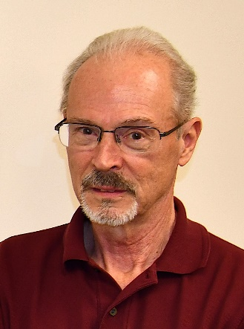
Thomas E. Lacher, Jr. (Professor Emeritus)
Phone: 979-255-6131
Email: tlacher@tamu.edu
Web page (not recently updated): https://biodiversitylabtamu.wordpress.com/

Research Interests, Projects, and Grants:
Ecology and conservation of macaw species in Peru; livestock, Mammalian biodiversity, and local communities in Huascaran National Park in Peru; Transboundary conservation of bats and agaves in the Texas and northern Mexico; Acoustic biology of nectar-feeding bats in northern Mexico; Models of white-nose transmission in bats in Texas and Mexico; Payment for ecosystem services and mammalian conservation on a landscape matrix in Costa Rica; Spatial ecology of sloths in Costa Rica; Fragmentation and mammalian biodiversity in Costa Rica; Population and community ecology of bats in the southern Brazilian Atlantic Forest; Cacao plantations and marmoset ecology in the Brazilian Atlantic Forest; Climate change and land-use impacts on amphibians in Colombia; Assessment and monitoring of globally threatened species of Rodentia, Eulipotyphla, and Scandentia.

Graduate Students and Their Research:
- Jessica Gilbert, Ph.D. The impacts and dynamics of the socio-ecological system of livestock grazing on biodiversity in the Huascaran Biosphere Reserve. Major Advisor.

Additional Information:
- Recipient of the Aldo Leopold Award from the American Society of Mammalogists
- Co-Chair IUCN Small Mammal Specialist Group
- Member, IUCN Climate Change Specialist Group
- Associate Conservation Scientist, Re:wild, Austin, Texas
- Co-Editor, Volumes 6 and 7, Handbook of the Mammals of the World and Volumes 1 and 2 of the Illustrated Checklist of the Mammals of the World

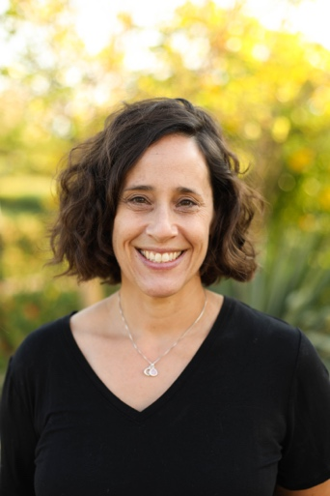
Jessica Light
Phone: 979-458-4357
Email: jessica.light@ag.tamu.edu
Web page: https://lightjessica.weebly.com/

Research Interests, Projects, and Grants:
I am an evolutionary biologist with a focus on phylogenetic, population genetic, and ecological interactions between parasites and their hosts. To address these broad research interests, I employ a variety of tools such as molecular (multiple genes, population genetic loci, or genomic data) and morphological data from field-collected and museum specimens. My lab is currently funded by the National Science Foundation on three separate projects: 1) Mid-career OPUS to study Peromyscus systematics; 2) Collaborative research exploring sucking louse phylogenetics and genomic and morphological selection; and 3) Thematic Collections Network to digitize mammal trait data from western North America.

Graduate Students and Their Research:
- Ayomiposi Abraham is a 3rd-year Ph.D. student interested in host-parasite associations, particularly those between pocket gophers and their chewing lice.
- Oluwaseun David Ajileye is a 3rd-year Ph.D. student interested in disease ecology, and tick and filarial worm associations.
- Brady Craft is a 3rd-year M.S. student pursing cranial morphology evolution in Peromyscus for her thesis research.
- Haley Ellis is a 3rd-year M.S. student pursuing limb morphology evolution in Peromyscus for her thesis reearch.
- Ali Lira is a 4th-year Ph.D. student interested in Neotropical bat flies, bats, and host-parasite coevolution.
- Grace Martindale is a 2nd-year M.S. student interested in Peromyscus external trait morphological evolution.

Undergraduate Researchers:
For the Spring 2025 semester, we have 10 undergraduate students assisting with various projects. Projects and undergraduate researchers include:
- Gopher-louse research: Katelyn Barlett
- Tick-filarial worm research: Holden Carey and Carlo Gonzalez-Soto
- Peromyscus: Connor Hastcoat, Katy Steakley, and Abigail Torres
- Bat flies: Connor Hastcoat and Abigail Torres
- Ranges digitization: Nicklaus Brawner, Avery Collazo, AnneMarie Johnston, Priscilla Solis

Staff and Technicians:
- Heather Prestridge is the lead collections manager of mammals at the Biodiversity Research and Teaching Collections
- Emily Coyote is our lead technician working on the RANGES project. Emily spends a lot of time in the collections recording specimen data and obtaining accurate georeference information.
- Danielle Dillard is investigating interactions between the giant kangaroo rat and a trombiculid mite. She also is interested in porcupine range expansions, lice parasitizing pocket gophers, and several other projects ongoing in the Light lab.
- Amanda Moehring is a curatorial volunteer in the Biodiversity Research and Teaching Collections.

Biodiversity Research and Teaching Collections:
The mammal division in the Biodiversity Research and Teaching Collections (http://brtc.tamu.edu) currently has over 68,500 specimens. Our data are available online through VertNet, iDigBio, and GBIF. The collections are currently staffed by Heather Prestridge, with the help of several volunteers and research interns.

Texas A&M University-Corpus Christi
Department Life Sciences, Texas A&M University- Corpus Christi, Corpus Christi, TX 78412
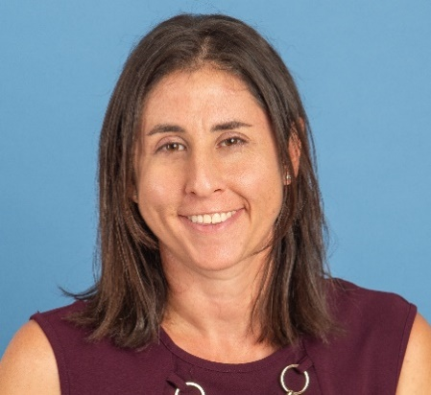
Dara Orbach
Phone: 361-825-3217
Email: dara.orbach@tamucc.edu
Web page: https://daraorbach.weebly.com/

Research Interests and Projects:
My research interests are the functional anatomy and behavioral ecology of marine mammals. My lab explores the evolutionary drivers of diverse genital morphology and coevolution between the sexes, health of dolphins, and population biology of local dolphins. My lab is particularly interested in how anthropogenic disturbances (e.g., vessel traffic, fishing interactions, contaminants) alter dolphin behavior, habitat use, and physiology. We use a variety of field-based techniques (e.g., photo-identification, theodolite tracking, unoccupied aerial systems, remote biopsy, passive acoustic monitoring) and laboratory tools (computer-assisted sperm analysis, geometric morphometrics, mass spectrometry) to advance science.

Postdoc Research:
- Lorenzo Fiori, Ph.D. Microbiome of marine mammals; body condition of bottlenose dolphins in different foraging contexts.

Graduate Student Research:
- Jackie Rich, Ph.D. student. Sperm biology of bottlenose dolphins
- Makayla Guinn, Ph.D. student. Metabolomics of and contaminants in bottlenose dolphins
- Emily McGhee, M.S. student. Acoustics of bottlenose dolphins in different foraging contexts

Undergraduate Student Research:
- Leala Punjabi, Honors/LSAMP student. Bottlenose dolphin behaviors in proximity to
industrial facilities
- Madison Hallmark, Honors student. Heavy metal contaminants in bottlenose dolphins
- Michelle Rodriguez, Honors student. Bottlenose dolphin whistles
- Soleil Delorge, LSAMP student. Swim tourism impacts on common dolphin swimming
- Taylor Rausch, Honors student. Site fidelity of bottlenose dolphins
- Aiden Adapathya, Honors student. Population estimates of bottlenose dolphins.

Additional Information:
- I am the current president of the Texas Society of Mammalogists
- I have supervised > 140 undergraduate students from groups historically underrepresented in STEM disciplines and serve as a faculty mentor to four professional organizations
- I do extensive public outreach that highlights the historic gender bias in the field of genital evolution

Texas A&M University-Kingsville
Feline Research Program, Caesar Kleberg Wildlife Research Institute

Michael Tewes (Retired)
Phone: 361-593-3972
Email: michael.tewes@tamuk.edu
Web page: https://www.ckwri.tamuk.edu/research-programs/feline-research-program

Research Interests, Projects, and Grants:
Small cats – ocelot, bobcat, jaguarundi, margay, clouded leopard, Asiatic golden cat, leopard cat, marbled cat; not-so-small: cougar and jaguar

Graduate Students and Their Research:
- Amanda Veals: Ph.D. student; examining resource selection and landscape connectivity of the ocelot in South Texas with the aim to help the Texas Department of Transportation plan for wildlife crossing structures to mitigate vehicle collisions for this endangered species
- Jason Lombardi: Ph.D. student; Factors of Ocelot Occupancy in South Texas (Collaborative Effort with East Foundation); Ocelot-Road Monitoring Project on FM 1847 in Cameron County, TX (Collaborative Effort with TXDOT)

Texas Parks and Wildlife Department
District 1 Diversity Biologist, Alpine, TX 79830

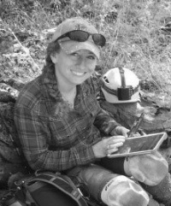
Krysta D. Demere
Phone: 432-244-9945
Email: Krysta.demere@tpwd.texas.gov
Research Interests, Projects, and Grants:
As a Diversity Biologist for Texas Parks and Wildlife, I supervise non-game research projects, provide technical guidance to private landowners regarding management and effective conservation actions for rare and threatened species, conduct outreach programs for landowners and the public, and conduct surveys for nongame species across the ~25 million acres that encompass the 16 counties of the Trans-Pecos Wildlife District. My efforts within the discipline of mammalogy for the past year have primarily focused on compiling a comprehensive database for historical and recent black bear observations, establishing a genetic tissue collection for black bear samples retrieved within west Texas, monitoring overwintering western bat species for the presence of Pd and potential development of white-nose syndrome, and investigating disease outbreaks in local lagomorphs. I have had the honor of serving as the official artist for TSM since 2018 and look forward to representing the society each year.

Texas State University

Department of Biology, San Marcos, TX 78666

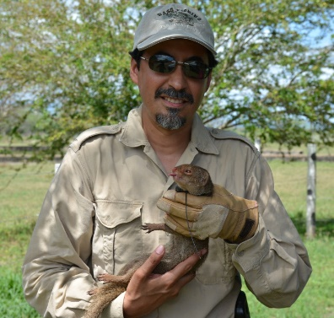
Ivan Castro-Arellano
Phone: 512-245-5546
FAX: 512-245-8713
Email: ic13@txstate.edu
Webpages:
https://www.bio.txst.edu/faculty-staff/ivan-castro-arellano.html
http://www.researchgate.net/profile/Ivan_Castro-Arellano

Research Interests, Projects, and Grants:
I use my background and training as an ecologist to address questions to understand the ecology of zoonotic diseases and invasive species. Because mammals are natural reservoirs for many zoonotic diseases, most of my work has been devoted to this taxonomic group, especially rodents and bats. Beyond my interest in disease ecology, I also have done research on theoretical aspects of community ecology, specifically on the analysis of assemblage-wide temporal niche overlap and elements of metacommunity structure. I address these questions using a variety of approaches that include modelling, null models, and analyses of both published and empirically data generated at my lab. Although my research interests are wide, they are intertwined and my goal is to integrate the study of community level dynamics in mammalian hosts to understand the dynamics of pathogen transmission.

Current Projects:
Although I have worked on multiple research topics and new ones develop based on new collaborations, I currently have three main lines of research at my lab:
- Ecology and evolution of activity patterns. Using publicly available large databases and fieldwork my lab is addressing multiple questions related to the ecological determinants of activity patterns and how this information can be used to understand the structure of mammalian assemblages worldwide. Another topic within this line is how anthropogenic changes can affect mammalian activity patterns and the implications for the ecology of these species.
- Host-vector ecology of Ornithodoros turicata in Central Texas. The ecology of soft ticks is a little known despite these tick species being vectors of zoonotic pathogens. At my lab, we are trying to ascertain which wild mammals serve the role of reservoirs for the pathogens vectored by these ticks and what role these have to disperse ticks among sites.
- Ecology of TX Kangaroo rat. With funding from TPWD and USFWS and in collaboration with Dr. Joe Veech (Texas State University), we have worked on different questions related to the ecology and conservation of this rodent species endemic to TX. This species is currently being considered for ESA listing and the generation of new knowledge is focused on the management for the conservation of this species.

Graduate Students and Their Research:
Current and recent graduate students
- Stoneham, Margaret (M.Sc. 2022). Temporal overlap among common mesocarnivores throughout the neotropics.
- Bergmanson, Stephanie (M.Sc. 2022). Comparison of Tapir species activity patterns across multiple sites in the neotropics.
- Reagan, Cassidy (M.Sc.). Elements of Metacommunity Structure for Bat Assemblages Across Elevational Gradients Worldwide.
- Ramirez, Rosa (M.Sc.). Integrating Host Community Ecology into the Disease Ecology of a Tick-Borne Relapsing Fever Vector.

I AM CURRENTLY SEEKING WELL QUALIFIED MS AND PhD STUDENTS THAT ARE INTERESTED IN THE TOPICS WE DO RESEARCH AT MY LAB. PLEASE CONTACT ME AT MY EMAIL IF INTERESTED.

Select past students
- Matt Milholland (PhD. 2017). Matt’s dissertation work was centered around the ecological correlates for hantavirus seroprevalence at different spatial scales.
- Sara Weaver (PhD. 2019). Sara worked on the effects wind energy production has on populations of bats at wind farm in south Texas.
- Madison Torres (M.Sc.). Madison’s thesis was on the home range dynamics of the invasive Small Asian Mongoose (Herpestes aeropunctatus) in Puerto Rico.
- Kathryn Michelle Benavidez (M.Sc. 2016). Michelle’s research was also in Puerto Rico and centered on the potential role of mongooses and commensal rodents as reservoirs of Leptospira, a zoonotic pathogen that has human health concern.
- Bradford Westrich (M.Sc.). Brad’s work was related to a NIH-funded grant centered about the population genetic dynamics and vector ecology of Ixodes scapularis. His thesis centered on the role of small and meso-mammals as hosts for this tick in eastern Texas.

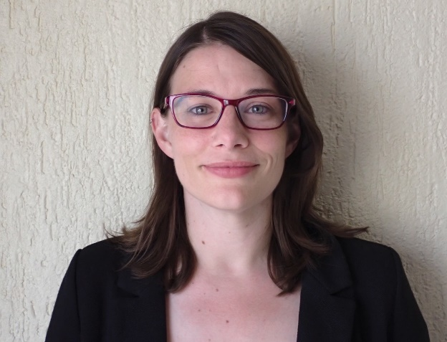
Leila Siciliano-Martina
Email: sicilia77@txstate.edu
Webpage: https://leilamartina.weebly.com/

Research Interests, Projects, and Grants:
My lab is focused on the relationship between animal traits and environmental conditions, particularly the ways in which human-modified systems (e.g., captivity, urbanization, changing climates) can influence organismal performance and phenotype. We explore functional traits (related to dietary, locomotor, physiological, and behavioral function) at the population and community-level to understand baseline trait-environment relationships as well as the ways in which traits can be modified by disturbances, and what this can tell us about species ecology, evolution, and conservation. We assess these topics using a combination of morphological size and shape analyses (e.g., traditional and geometric morphometric techniques), spatial analyses, and ecological modeling.
Graduate Students and their research:
- Sam Lamb – MS thesis student – Fall 2023 to present - Morphological and dietary variation of gray foxes (Urocyon cinereoargenteus) across urban gradients
- Alyssa Arguijo – MS thesis student – Spring 2024 to present – Morphological differentiation of red wolves (Canis rufus) in captivity.
- Matt Bushell – Ph.D. student – Fall 2024 to present – Evolution of hypercarnivorous trait morphology in carnivorans.

Texas Tech University
Department of Biological Sciences, and Natural Science Research Laboratory, Museum of Texas Tech University, Lubbock, TX 79409

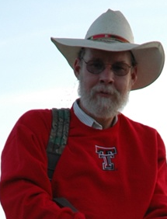
Robert D. Bradley
Phone: 806-834-1303
Email: robert.bradley@ttu.edu
Web page: https://www.depts.ttu.edu/biology/people/Faculty/Bradley/, https://www.depts.ttu.edu/nsrl/directory/faculty_curators/bio/robert-bradley.php

Research Interests, Projects, and Grants:
My research interests include: systematic relationships, molecular evolution, genomics, and natural history of mammals, particularly in the cricetid and geomyoid rodents; determining the genetic basis for adaptation in Peromyscus; examination of hybrid zones between genetically distinct taxa; understanding isolating mechanisms and the dynamics of genetic introgression; exploring the utility and application of the Genetic Species Concept; examination of the origin and evolution of rodent-borne viruses, especially in the use of rodent phylogenies and genetic structure to predict the transmission and evolution of viruses; various wildlife diseases such as chronic waste disease in deer, pneumonia in bighorn sheep, modeling predictions associated with epidemiology and the impacts of climate change; diets, genetics, and conservation of Texas Black Bears and Mt. Lions, and growth and utilization of natural history collections, especially those pertaining to mammals.

Current Projects:
- Systematics of the genus Peromyscus
- Use of genomic methods to investigate speciation and adaptation in Peromyscus
- Effects of the zonadhesin gene in speciation of mammals
- Hybridization between white-tailed and mule deer
- Detection methods of Chronic Wasting Disease in cervids
- Genetics of transplanted populations of bighorn sheep in Texas
- Phylogenetic relationships of Neotomine and Reithrodontomyine rodents
- Systematic and genome studies of the genus Cratogeomys, Geomys, and Thomomys
- Ecology of hanta- and arenaviruses in the southwestern US and Mexico
- Morphology, landscape genomics and effective population size of the Palo Duro Mouse, Peromyscus truei comanche
- NSF funded project “A Partnership to Facilitate Scientific Inquiry into the Vast Functional Trait Diversity of Phyllostomid Bats” (Richard Stevens – project PI)
- NSF funded project “Advancing Digitization of Biodiversity collections: Collaborative Research: Ranges: Building Capacity to Extend Mammal Specimens from Western North America” (Richard Stevens – project PI)
- Use of next-gen methods for detecting zoonoses
- Detection of novel viruses using metagenomics in Sylvilagus
- Detection of pneumonia in bighorn and aoudad in Texas
- Taxonomic catalogs of terrestrial vertebrates described exclusively from Texas (David J. Schmidly and Lisa Bradley - PIs)
- Illustrated key to the Mammals of Texas (David J. Schmidly, Richard Stevens, Lisa Bradley, Robert Dowler, and Katelyn Albrecht Co-PIs)
- Detection of prion disease genes across Mammalia

Graduate Students and Their Research:
- Joanna Bateman (PhD candidate) is in her 7th year and is using genomic methods to determine speciation and evolutionary processes in heteromyid rodents.
- Macy Krishnamoorthy (PhD candidate) is in her 8th year and is co-chaired by Dr. Richard Stevens. Macy is examining bat feeding and pollination impacts on baobab trees, and other bat questions.
- Katelyn Albrecht (MS student – but transitioning to a PhD student) is in her 3nd year and is co-advised by Dr. Richard Stevens. Katelyn is using 3D scans of bats to learn more about wing variation in Phyllostomids.
- Sufia Akter Neha (PhD student) is in her 3nd year. Her research project will involve microbiome analyses of bear and mountain lions.
- Emily Schmalzried (MS student) is in her 2nd year. Her thesis will involve next-gen methods for detecting zoonoses.
- Brendan Amman (MS student) is in his 1st year.

Undergraduate Students and Their Research:
- Last year, 5 undergraduate students worked in the research lab.

Researcher Technician:
- Georgina Brugette is the Lab as a technician and is spearheading the project involving the use of next-gen methods for detecting zoonoses. In addition, she is assisting on several other mammal projects.

Additional Information:
· I retired as a faculty member from the Department of Biological Sciences and am working part-time in my role as Director of the Natural Science Research Laboratory. I will be appointed Professor Emeritus soon, so I can finish my graduate students.
· As Director of the Natural Science Research Laboratory, Museum of Texas Tech University, I would be pleased to address questions about loans, visits, or resources.
· In addition, I am editor of the publication series (Occasional Papers and Special Publications) at the Natural Sciences Research Laboratory, Museum of Texas Tech University. We are seeking to increase the number of contributions to these two series, so please, send us your manuscripts!

Of interest to TSM members
· In the Summer of 2024, the updated checklist for Texas Mammals was published. Schmidly, David J., Robert D. Bradley, Franklin D. Yancey, II, and Lisa C. Bradley. Comprehensive Annotated Checklist of Recent Land and Marine Mammals of Texas, 2024, with Comments on their Taxonomic and Conservation Status. Special Publications, Museum of Texas Tech University 80:1-76.
· In the Summer of 2023, a catalog of Texas vertebrates was published. Schmidly, David J., Bradley, Robert D., Lisa C. Bradley, and Franklin D. Yancey II (editors). Taxonomic catalogs for the recent terrestrial vertebrates (species and subspecies) described from Texas. 2023. Special Publications, Museum of Texas Tech University 77:iii+1-385.

· In the Summer of 2022, Texas Natural History in the Twenty-first Century, by David J. Schmidly, Robert D. Bradley, and Lisa C. Bradley was published by Texas Tech University Press. This book provides an updated synopsis of Texas natural history. In this version, an effort was made to include information for amphibians, reptiles, and birds as obtained by members of the Bureau of Biological Survey. In addition, the information for mammals was updated and expanded.
· In the Fall of 2019, the Memorial Volume for the Dr. Robert J. Baker was completed and provides a synthesis of the career of one of the most ardent supporters of TSM. It is available on the NSRL website and is cited as follows: Bradley, Robert D., Hugh H. Genoways, David J. Schmidly, and Lisa C. Bradley. 2019. Overture. Pp. v-ix in From field to laboratory: A memorial volume in honor of Robert J. Baker (R. D. Bradley, H. H. Genoways, D. J. Schmidly, and L. C. Bradley, eds.). Special Publications, Museum of Texas Tech University 71:xi+1-911.
· In 2019, Dr. Robert Dowler and I were invited to write a summary of North American Mammalogical Research for the Centennial Issue of the Journal of Mammalogy. This manuscript (see below) provides useful information for students and faculty who are interested in the history of mammalian research methods. Bradley, Robert D., and Robert C. Dowler. 2019. A century of mammal research: changes in research paradigms and emphases. Journal of Mammalogy, Centennial Issue 100:719-732.
· In 2017, David Schmidly led an effort to publish a timeline of important events in North American Mammalogy; this effort resulted in the manuscript (see below) that provides useful information for students (think qualifying exams), faculty, and historians. Schmidly, David J., Robert D. Bradley, Lisa C. Bradley, and Richard D. Stevens. 2017. A timeline of significant events in the development of North American mammalogy. Special Publications, Museum of Texas Tech University, 66:1-37.

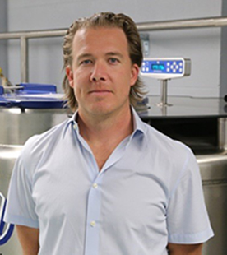
Caleb D. Phillips
Phone: 806-834-8181
Email: caleb.phillips@ttu.edu
Web pages: www.biol.ttu.edu, www.nsrl.ttu.edu

Research Interests, Projects, and Grants:
The Phillips laboratory studies metagenomes, genomes, craniofacial development, as well as some morphology and molecular mammalogy. The lab is currently supported by Texas Parks and Wildlife Department, the NIH, and NSF.

Graduate Students and Their Research:
- Rebecca Gabrilska (PhD student): Chronic wound microbiomes and how they are influenced by human genetics
- Khalid Omeir (MS student): Microbiome-transcriptome-wide association of bacteria in chronic wounds
- Jacob Ancira (MS student): Structural equation modeling to predict wound healing time based on wound microbial composition
- Hendra Sihaloho (PhD student): Community assembly of microbiomes of forest interior bats of Malaysia
- Sufia Akter Neha (PhD student, co-advised with Robert Bradley): Microbiomes of black bears

Additional Information:
My teaching responsibilities include Bioinformatics, Metagenomics and Organic Evolution. These courses are offered at both graduate and undergraduate levels. I am also Curator of Genetic Resources at the Natural Science Research Laboratory.

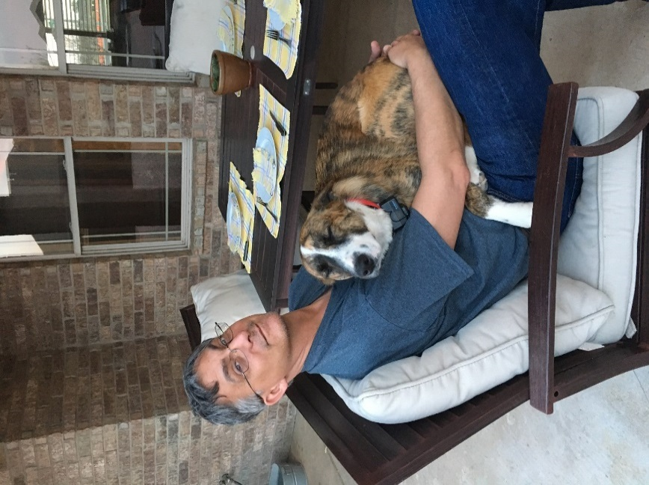
Richard D. Stevens
Department of Natural Resources Management, Lubbock TX 79409
Phone: 806-834-6843
Email: richard.stevens@ttu.edu
Web page URL: https://richardstevens29.wixsite.com/my-site

Research Interests, Projects, and Grants:
- Patterns of biodiversity of New World bats.
- Conservation of Atlantic Forest bat communities.
- Metacommunity structure of rodents of the Mojave Desert.
- Dispersal and metapopulation dynamics of Texas Kangaroo rats.
  - Use of Highway Structures by Bats in the Trans-Pecos and East Texas.
  - Trans-Pecos bat community structure
Graduate Students and Their Research:
- Garret Langlois was a Ph.D. student working on the roosting ecology and behavioral network structure of great fruit-eating bats (Artibeus lituratus) in Atlantic Forest of Paraguay. Garret has graduated and currently works for the Lubbock Arts & Intersections Research (LAIR) group.
- John Stuhler—John is a Ph.D. student that completed his M.S. at the University of Wisconsin. He is interested in the ecology/conservation biology of Texas kangaroo rats and is conducting an intensive study of habitat preferences. He is also interested in large-scale diversity patterns in heteromyid rodents. He is currently the Collections Manager of Mammals at the University of Wisconsin-Madison Museum of Zoology.
- Jenna Grimshaw is a Ph.D. student co-advised by David Ray and me. She earned an M.S. at Tarleton State University studying patterns of phylogenetic diversity of Mexican bats. Her current research is to identify patterns of genetic structure in three species of critically-imperiled Louisiana bats: Myotis austroriparius, M. septentrionalis, and Eptesicus fuscus. More specifically, she aims to determine if each of these three species comprise a single population or multiple genetic subpopulations with little gene flow. She is also interested in the distribution of transposable elements among mammalian genomes from a genomic ecological perspective. She is currently a Visiting Instructor at Tarleton State University.
- Holly Wilson—Holly is a Ph.D. student earned her M.S. from Fort Hays State University under Elmer Birney. She is interested in how bats use highway structures as day-roosts in the Trans-Pecos of Texas.
- Clint Perkins—Clint is a Ph.D. student who recently earned his M.S. from Angelo State University under Bob Dowler. His project revolves around population and spatial ecology of the plains spotted skunk, Spilogale putorius interrupta.
- Macy Madden—Macy is a Ph.D. student co-advised by Robert Bradley and me. She is interested in plant-pollinator interactions between baobab trees and Rousettus aegyptiacus and Epomophorus species in South Africa and Kenya.
- Angela Alviz—Angela is a Ph.D. student who received her M.S. in Biology from the Pontificia Universidad Javeriana. Angela is interested in Tapir metapopulation dynamics in Colombia.
- Emma Sanchez was recruited into the lab to do her M.S. on use of culverts as day roosts by bats in east Texas. She graduated and is currently working for the Texas A&M Natural Resources Institute
- Amanda Newman joined the lab as a M.S. stuent last year after completing her B.S. at TTU. She is interested in how bats use highway right-of-ways as habitat.
- Jayme Czap also joined the lab last year after completing her B.S. at TTU and is working on her M.S. She is interested in how bats select bridges as day roosts in east Texas.
- Manuel Quispe Lopez is from Peru and just started in the lab. He will be working on bat community structure in the Trans-Pecos.

Texas Tech University/University of New Mexico
60 Homesteads Rd., Placitas, New Mexico 8704

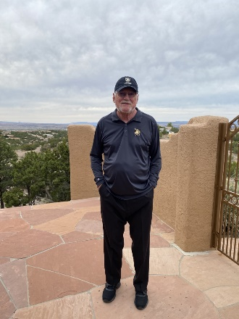
David J. Schmidly
Retired President and Professor Emeritus
Phone: 505-288-9722 (cell)
Email: djschmidly@gmail.com

Research Interests: Natural History, Systematics, and Conservation of Texas Mammals

Projects: In 2024 I joined with colleagues Robert D. Bradley, Frank Yancey, and Lisa Bradley to publish a “Comprehensive Annotated Checklist of Recent Land and Marine Mammals of Texas, 2024, with Comments on Their Taxonomic and Conservation Status.” A total of 206 species are included in the checklist, including 148 native terrestrial species, 28 domestic, feral, and introduced species, and 30 marine mammals that have stranded on Texas beaches or been observed in the state’s offshore waters. This is the first checklist publication to include information on all three of these groups of mammals.

Publications planned for 2025 include “The Type Localities of Texas’ Species and Subspecies of Mammals,” and “William Blaney Richardson (1868-1927): Natural History Explorer and Specimen Collector in Latin America.” For another 2025 publication, I have co-authored with Robert Bradley and Frank Yancey species accounts for the 11 taxa in the Peromyscus boylii species complex to be included in a new book “Handbook of the Mammals of Middle and South America: Rodentia—Cricetidae” that is being edited by Dr. Livia Leon-Paniagua and some of her Mexican colleages for publication in a book by Springer Nature.

My website www.davidschmidlyphd.com continues to highlight the books and publications I have produced over the years as well as other aspects of my career.

Aside from this work, I will continue recovering from cancer treatment.

Trinity University
Department of Biology, One Trinity Place, San Antonio, TX 78212

David O. Ribble
Phone: 210-999-8363
Email: dribble@trinity.edu
Web page: www.trinity.edu/
Research Interests, Projects, and Grants:
I am interested in the evolutionary ecology of small mammals, including Peromyscus and elephant-shrews. My research in recent years has ranged from studies of social organization to mating behavior to thermal ecology. I have recently been leading a course in Costa Rica where we are monitoring the elevational distribution of small mammals on the Pacific Slope from Monteverde to the coast. I now serve as Dean of the newly established D. R. Semmes School of Science at Trinity. While my own research agenda has diminished, I am enjoying supporting and promoting others at Trinity University.

Washington and Lee University
204 W. Washington St., Lexington, VA 24450
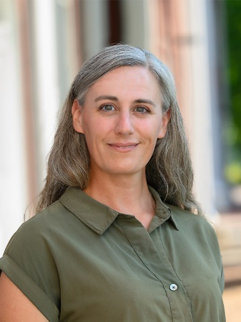
Jessica Healy-La Price
Phone: 540-458-8974
Email: jlaprice@wlu.edu

Research Interests, Projects, and Grants:
My primary area of study is the physiological ecology of ground squirrels that hibernate. Using both laboratory and field populations of thirteen-lined ground squirrels, I investigate interactions between hormones that control food intake and reproduction. A current project involves understanding sex differences in estradiol function in early active season hibernators. Another collaborative project involves investigating the latitudinal differences in hibernation patterns in thirteen-lined ground squirrels from Texas to Canada.

Undergraduate Students and Their Research:
- Kylee Cross & Brian Lee – Physiological regulation of hibernation to active season transition in ground squirrels
- Christina Ziccardi & Whitney Obialor – Hormone secretion profile of active-season ground squirrels

Additional Information:
- I teach a variety of undergraduate courses in ecophysiology and field mammalogy, including a travel term course to Panama.
- I’m currently Secretary of the Board of the International Hibernation Society.

University of Central Oklahoma
Department of Biology, Center for Wildlife Forensic Science and Conservation Studies, Edmond, OK 73034
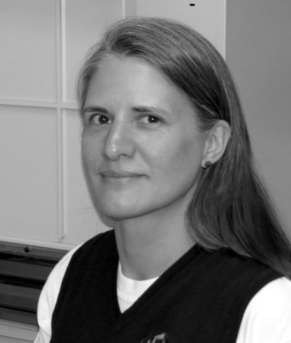
Michelle L. Haynie
Phone: 405-974-5774
Email: mhaynie@uco.edu
Web page: https://www3.uco.edu/centraldirectory/profiles/731091
Research Interests, Projects, and Grants:
My research focuses on mammalian evolution biology, primarily in population genetics and molecular systematics. I am interested in using genetic markers to address conservation and evolutionary questions, with most of my research focusing on comparative hybrid zone studies and the identification of cryptic species. I also am interested in factors that impact how small populations and communities change over time.

My current projects include:
- An evaluation of bobcat genetic diversity and structure in Oklahoma
- A long-term small mammal mark-recapture survey at UCO’s Selman Living Lab to identify factors that impact population and community persistence (with Francisca Mendez-Harclerode, Gloria Caddell, Chad King, Sean Laverty, Richard Dolman, and Chris Goodchild)
- A survey of mammals at an old oilfield site and comparison of species diversity and richness between this site and a paired site in Cushing, Oklahoma
Graduate Students and Their Research:
- Claire Wiley – Hantavirus survey of small mammals at Selman Living Lab; genetic identification compared to field identification of small mammals at Selman Living Lab
- Nadiya Cavallo - A comparison of species richness, species diversity, and trap success on disturbed lands in Cushing, Oklahoma; genetic diversity in Peromyscus populations across Oklahoma

Undergraduate Students and Their Research:
- Kayli Newport – Assisting Claire with genetic species identification of Selman rodents, focusing on Peromyscus
- Savannah Glidewell – Assisting Claire with genetic species identification of Selman rodents
- Lillian Gunelson – Identification of internal and external parasites from small mammals at Selman Living Lab (in association with Dr. Wayne Lord); graduated December 2024
- Liliana Ballon – Identification of internal and external parasites from small mammals at Selman Living Lab; identification of microplastics in rodent fecal pellets
- Joshua Walker – Identification of internal and external parasites from small mammals at Selman Living Lab; identification of microplastics in rodent fecal pellets

Additional Information:
- After many years, Mammals of Oklahoma, Second Edition is finally complete! It became available for purchase in July 2024.

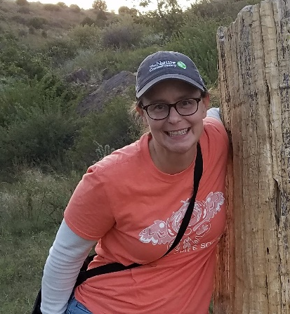
Vicki Jackson
Phone: 405-974-5480
Fax: 405-974-5726
Email: vjackson4@uco.edu

Research Interests, Projects, and Grants:
My research interests include spatial ecology and captive wild animal care.

My current projects and grants include:
- Mesocarnivore survey of riparian corridors and gorges in Creek County, OK
- Development of wildlife forensics curriculum to use in higher education
Undergraduate Students and Their Research:
- Efficacy of bait to lure carnivores and herbivores in camera surveys
- Identification of important characteristics to identify bobcat fur through microscopy

University of Mary Hardin-Baylor
Department of Biology, Box 8432, UMHB Station, Belton, TX 76513


Cathleen Early
Phone: 254-295-5041
Email: cearly@umhb.edu
Web page: https://www.umhb.edu/resources/hr/directory/cathleen-early#1845

Research Interests and Projects:
I am a field biologist primarily interested in behavioral ecology. I am also interested in STEM education research, especially how to improve curriculum to be more effective for first generation students.

While I am not currently conducting research or mentoring research students, I support student research by helping judge student presentations at conferences I attend. I bring undergraduate students to the Texas Academy of Science meeting every year, including students who are not presenting that year.

Additional Information:
I am passionate about making science fun and approachable for all age groups. In 2006, I helped establish the annual Science Saturday event at UMHB, a hands-on STEM event for K-5th grade. I continue to serve as the coordinator of this event and would be happy to share tips with anyone thinking about setting up something similar at their campus.

University of Michigan
Museum of Zoology, 3600 Varsity Drive, Ann Arbor, Michigan 48109

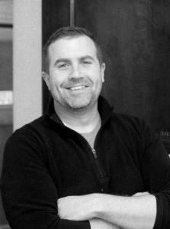
Cody W. Thompson
Phone: (734) 615-2810
Fax: (734) 763-4080
Email: cwthomp@umich.edu
Web page: codythompson.org

Research Interests, Projects, and Grants:
I consider myself a classically trained mammalogist, and as such, I use knowledge gained from observations made during fieldwork and through the examination of museum collections to answer questions about mammalian diversity. My research program focuses broadly on investigating the evolutionary patterns and processes that generate mammalian diversity. I also leverage natural history collections in the context of the extended specimen to examine museum voucher specimens in new and novel ways, e.g., emerging infectious diseases. My lab currently is funded by the National Science Foundation (Awards #2101909 and 2228389) and the National Institute of Health (Project # 1R15AI80994-01). We are also funded by the Belmont Forum.

Students and Their Research:
- Josie Anderson – Mammalian Trait Data
- Paloma Calvin – Mammalian Trati Data
- Ava Fraleigh – Bat Immunology
- Sam Henry – Bat Development
- Katie Kinney – Rodent Morphology

Other Lab Personnel:
- Nepsis Garcia – Graduate Curatorial Assistant
- Ramon Nagesan – CT Lab Manager
- Haley Martens – CT Lab Technician

Additional Information:
I joined the Mammal Division at the University of Michigan Museum of Zoology (UMMZ) in June 2013. The UMMZ is administered by the Department of Ecology and Evolutionary Biology (EEB). I serve as the UMMZ Mammal Collections Manager and maintain a research appointment in EEB. With these two roles, I am fully involved in all aspects of the UMMZ Mammal Division, and I enjoy the challenge of integrating my experience working in museum collections with my own research program.

The University of Texas at Austin
Texas Memorial Museum, 2400 Trinity St. Stop D1500, Austin, TX 78712

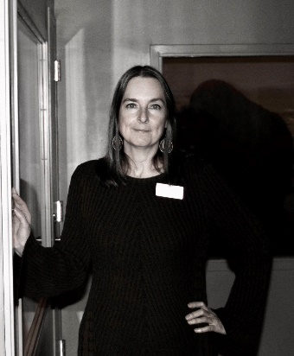
Pamela R. Owen
Phone: 512-232-5511
Email: p.owen@austin.utexas.edu
Web page: https://sciencemuseum.utexas.edu/

Research Interests, Projects, and Grants:
- Evolutionary history of American badgers (Taxidiinae).
- Late Cenozoic mammalian faunas: I continue work on late Pleistocene mammal remains from the Slaughter Creek Site in southeastern Travis County. There are some intriguing taxa from this site, including: antilocaprids Capromeryx and Antilocapra, a llama-like camelid, canids (Canis dirus, C. latrans, and C. lupus), and a machairodont felid. Other taxa identified include Bison, Odocoileus, and Equus.
Additional Information:
As Associate Director of Texas Science & Natural History Museum, I am focused on updating and developing new exhibits and experiences as part of a revitalization effort for the museum, which reopened in September 2023. I continue to serve as an Associate Editor for Mammalian Species (fossil record section) and provide annual training in mammalogy for several chapters (Balcones Canyonlands, Capital Area, Gideon Lincecum, Good Water, Hays County, Highland Lakes, Lindheimer, and Lost Pines) of Texas Master Naturalists.

University of Houston—Downtown
Department of Natural Sciences, 1 Main Street, Houston, TX 77002

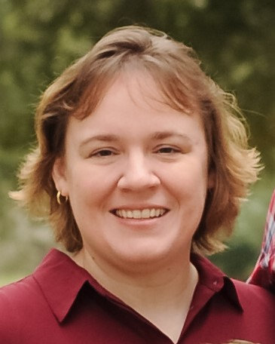Amy Baird
Phone: 713-222-5301
Email: BairdA@uhd.edu
Web page: https://bairdlab.wordpress.com/

Research Interests, Projects, and Grants:

My research interests include molecular phylogenetics, phylogeography, and speciation of mammals. Current projects include molecular phylogenetics and taxonomy of lasiurine bats, including phylogeography of the Hawaiian Hoary bat; population genetics of bowhead whales (grant funded through the North Slope Borough); and genetic identification of bowhead whale parasites. I am partially funded by a grant from the North Slope Borough (PI) and an Organized Research and Creative Activities grant through UHD (PI)

Undergraduate Students and Their Research:

Junior Tankoh, Alexandra Hernandez, and Alexandria Estimable are examining population genetics of bowhead whales

U.S. Centers for Disease Control and Prevention
CDC Biorepository, Atlanta, GA 30345

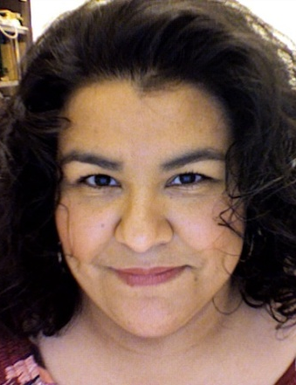
Marcia (Marcy) A. Revelez
Phone: 404-498-1665
Email: mrevelez@cdc.gov
Web page URL: https://www.cdc.gov/csels/dls/cdc-biorepository.html
Research Interests, Projects, and Grants:
I have over twenty years of experience working in natural history collections, primarily with mammal and genomic collections. I am now the Lead and Collections Manager for the CDC Biorepository, which is made up of approximately 6.6 million specimens from research, surveillance, and emergency response efforts at CDC, including the COVID-19 response. My role is to modernize the biorepository, with emphasis on policy and collection stewardship. Research interests revolve around best practices, collections management, data management, and IPM. I am part of a new endeavor to create a preparedness repository for CDC, to facilitate public health response to emergency outbreaks in the U.S.

Additional Information:
Member, Federal Interagency Working Group of Scientific Collections (IWGSC); member, Enviro-Bio Group for International Society of Biological and Environmental Repositories; member, Biobanking standards for International Organization for Standardization (ISO); member, workgroup National Plan for digitization of biodiversity collections (Network Integrated Biocollections Alliance (NIBA)), Biodiversity Collections Network (BCoN); member, Diversity and Equity Committee, Society for the Preservation of Natural History Collections (SPNHC); member, Systematics Committee, American Society of Mammalogists (ASM)

Fellows and Their Research:
- Taylor Soniat, Collections Specialist - Taylor is examining optimal storage conditions and sample viability at the CDC Biorepository
- Elizanette Lopez, Biorepository Fellow – Elizanette is examining sample management as it applies to the CDC Biorepository
- James Austin, Biorepository Fellow – Jamie is also examining sample management and best practices as it applies to sample disposition at the CDC Biorepository
- George Xiang, Communications Specialist – George is examining ways to improve communications and project management as it relates to sample management at CDC

